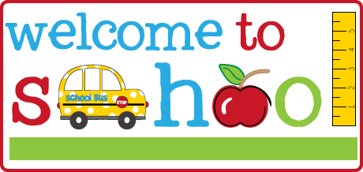

Mrs. Jefferson & Mrs. Darline’s Supply List 2023-2024

- $25 classroom fee (to include My Big World scholastics magazine)
- Family Picture (to be displayed on our family wall)
- LARGE BACKPACK to hold lunch box and folder (minimum approx. 16x12, not toddler size)
- Lunch Box/Bento Box (that the child can open themselves)
- 2 Pocket folder (solid plastic)
- (2) Boxes of CRAYOLA CRAYONS 24 PACK (Classic Colors, NOT Washable)
- (1) Box of CRAYOLA MARKERS 10 PACK (Classic Colors)
- (1) CRAYOLA WASHABLE WATERCOLOR PAINT SET (8 colors)
- (3) 3 Pack of Elmers Glue Sticks
- (1) Pair of Fiskars scissors-round tip
- (1) Can of Play-Doh (any color)
- (2) Containers of Clorox or Lysol Wipes
- (2) Clorox or Lysol Disinfectant Spray Cans
- Primary Color Cardstock or Laminating Sheets
- Change of clothes- pants, shirt, socks and two (2) pair of underwear. Place in a Ziplock bag with CHILD’S NAME on the bag.

OFFICES SUPPLIES

1 REAM OF COPY PAPER

Please put your child’s name on the following:

- Backpack
- Lunch box
- All clothing- including coats and sweaters

