Mrs. Levesque’s Kindergarten Supply List
Classroom Fee: $25

General Learning:
- 1 backpack large enough to fit lunch box and take-home folder
- 2 plastic folders with prongs and pockets
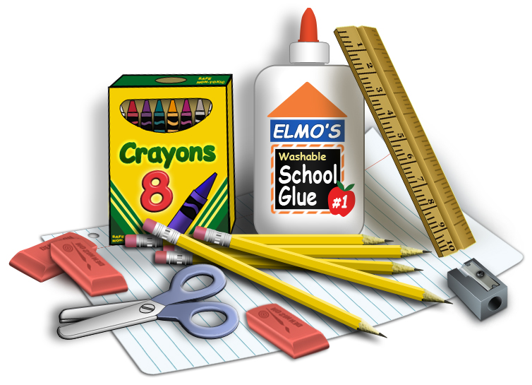
- 2 boxes of 24 pkg Crayola crayons
- 1 box of Classic color magic markers 10 ct.
- 2 thin Expo markers
- 1 yellow wide-ruled spiral notebook
- 1 pkg of Colored card stock
- 10 small glue sticks
- 2 bottles white glue 4oz
- 1 pair of Scissors
- Playdough 4 pack
- 1 box of Tissues
- 2 rolls of Paper Towels
- 1 bottle of Hand Sanitizer
- 1 container of Clorox/ Lysol wipes
- 1 box of Ziploc Baggies (gallon or quart size)
- Set of extra cloths for emergency (does not need to be uniform)

Office Supplies:
- 1 ream of copy paper

