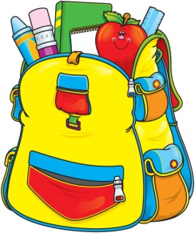
Mrs. Lindsey & Mrs. Becky’s
2-Day 4’s
Supply List 2023-2024

One plastic two pocket folder (for correspondence between parents and teachers)
One CRAYOLA watercolor paint set (8 Colors)
Two boxes CRAYOLA crayons (24 Pack)
One box CRAYOLA washable markers (Classic Colors 10 Pack)
Two bottles Elmer's glue (White 4oz)
Ten Elmer's glue sticks (Purple preferred)
One pair of kid scissors
Two containers Lysol wipes (preferably in the yellow container)
One can of Lysol spray
One bottle foaming hand soap (Antibacterial)
One pump bottle hand sanitizer
One box of gallon size Ziploc bags
One package of Baby Wipes

One family picture (to be displayed in class all year)
One change of clothing in labeled Ziploc bag (to remain in classroom)
$25 classroom fee

OFFICE SUPPLIES
1 REAM OF COPY PAPER

Please make sure student has a standard size book bag to use on a daily basis to carry folder, lunch box, snack and crafts, etc.

Please clearly label folder, lunch box, spill proof cup, family picture, change of clothing and book bag.

All other supplies will be shared and do not need to be labeled.

