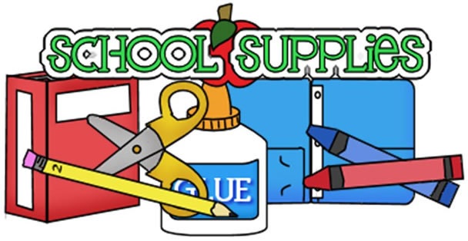
Mrs. Thompson's 3 day 4’s Supply List

(THESE ITEMS DO NOT NEED TO BE LABELED)

- 1 Box CRAYOLA CRAYONS 24 PACK (Classic Colors not washable)
- 6 Elmer’s Glue Sticks
- 1 Pack of WHITE cardstock
- 1 Bottle of hand sanitizer
- 1 Container of baby wipes
- 1 Bottle of Clorox/Lysol Cleaner (bleach free)
- 2 Containers of Clorox Wipes
- 1 Box of tissues
- 1 2 Pack of EXPO Markers
- 1 Hand Soap
- 1 Box of Quart Size Bags

Please put your child’s name on the following:

- 1 Backpack (NO MINI- MUST FIT REGULAR SIZE FOLDER and Lunch Box)
- 1 Lunch box
- 1 Two-pocket plastic folder
- 2 Wide-Ruled spiral notebooks (with lines)
- 1 Change of clothing (season appropriate) in Ziplock Bag- labeled with child’s name
- 1 4x6 Family Photo (to be displayed on our “family wall”)
- $25.00 Classroom fee

OFFICE SUPPLIES
1 Ream of Copy Paper

